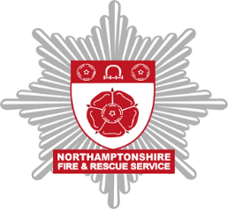

Request a visit to a commercial premises or advice from Fire Protection

Data protection agreement

In this form, we will ask for some personal information (such as name, address, postcode) in order to fulfil your request for information or services.

This information will be held securely and will be used to provide you with the service you have requested.

Any processing will be performed in line with the requirements of the Data Protection Act 2018 and the General Data Protection Regulation.

The Service is registered as a Data Controller with the Information Commissioner’s Office under the reference number ZA482017. Further details about how we process personal data can be found in our privacy notice.

Please complete this form if you need any advice on business fire safety from our Fire Protection team or if you require a visit to your business premises from a Fire Protection Officer.

Section 1 – About you

Full name
Email address
Contact number

Section 2 – About the premises

What are you requesting? | Advice on business fire safety |  | ☐ | A visit from a Fire Protection Officer | ☐
Please give us further details about your request

Also give us as much detail as possible on the premises in question (e.g. opening hours, is this an established or new business etc.)
What is the type of business/premises? | Caravan site | ☐ |  | Factory or warehouse | ☐
 | Farm | ☐ |  | Flats | ☐
 | Hospital | ☐ |  | Hotel or boarding house | ☐
 | House in Multiple Occupation (HMO) | ☐ |  | Licensed venue (public house, restaurant, night club) | ☐
 | Nursery | ☐ |  | Office | ☐
 | Other residential | ☐ |  | Other non-residential | ☐
 | Public building | ☐ |  | Community or village hall | ☐
 | Residential care home | ☐ |  | School | ☐
 | Shop | ☐ |  | Sports centre | ☐
What is the name of business/premises?
Full address of business/premises

Thank you for completing this form, please email it to fireprotection@northantsfire.gov.uk and a member of the Fire Protection Team will be in touch with you shortly.

