# FIRE AND RESCUE PRE-APPLICATION INFORMATION, ADVICE AND GUIDANCE FOR DEVELOPERS DESIGNING NEW RESIDENTIAL AND COMMERCIAL DEVELOPMENT SCHEMES IN NORTHAMPTONSHIRE

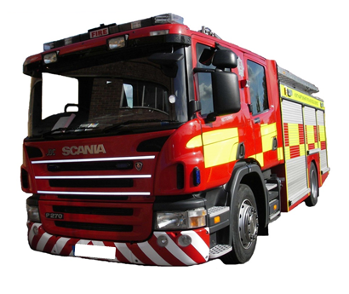

**PRODUCED BY NORTHAMPTONSHIRE FIRE AND RESCUE SERVICE (NFRS)**

Table of Contents

1 Introduction and scope 3

2 Access and facilities for the Fire Service 3

3 Water supplies for firefighting 5

4 Regulatory Reform (Fire Safety) Order 2005 7

5 Goodwill advice 8

6 Planning out crime in Northamptonshire 10

7 Final thoughts 11

# 1 Introduction and scope

This document has been produced by NFRS to provide information, advice and guidance to developers and support Local Planning Authorities (LPAs) on issues relating to fire safety at the development control stage when designing new residential and commercial development schemes.

When a planning application is submitted to the local Planning Department the Fire Service are consulted and where relevant, invited to make comment on the appropriate fire safety requirements for the application.

It is recognised that some of the information and guidance detailed within this document are not classed as material planning considerations as they are controlled through other legislation such as the Building Regulations, or support guidance provided by other consultees, for example Northamptonshire County Council’s (NCC’s) Highways department.

However, we would recommend and encourage that where information is not able to be considered as a material planning consideration the information/guidance contained within is still considered by developers as advice/information and implemented within development schemes as appropriate.

Dependent upon the type and size of the project our advice will concentrate on four key factors:

1. Access and Facilities for the Fire Service
2. Water Supplies for Firefighting
3. Regulatory Reform (Fire Safety Order) 2005
4. Goodwill Advice (including housing developments)

# 2 Access and facilities for the Fire Service

If the application involves the construction of a building you will be required to provide reasonable facilities for the Fire Service. In most circumstances this will mean providing vehicular access for fire appliances. It is important to remember that failure to do so may prevent the applicant from obtaining a completion certificate under the Building Regulations.

**Vehicle access - domestic dwellings**

There should be vehicle access for a pump appliance to **within 45m of all points within the dwelling house.**

Every elevation to which vehicle access isprovided in accordance with the above paragraph should have a suitable door(s), not less than 750mm wide, giving access to the interior of the building.

A vehicle access route may be a road or other route which, including any inspection covers and the like, meets the standards in Tables 1 and 2 below.

Turning facilities should be provided in any dead end access route that is more than 20m in length. This can be by a hammerhead or turning circle. Private driveways are not an acceptable alternative.



**N.B When taking into consideration the Firefighter travel distance , measure the 45m back from the furthest point of the dwelling before deciding the finishing point of the road or other suitable surface.**

A

A

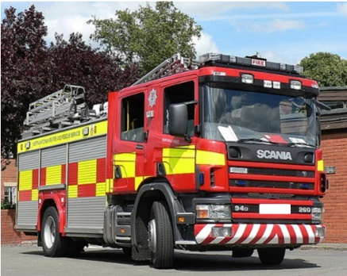

B

C

**A** = Furthest point of the building

**B** = Fire Service entry point

**C** = Fire Service vehicle access point

**A to B to C must be less than or equal to 45m**

**Vehicle access - commercial property and blocks of flats not fitted with fire mains**

There should be vehicle access for a pump appliance to small buildings (those of up to 2000m2 with a top storey up to 11m above ground level) to either:

* 15% of the perimeter; or
* Within 45m of every point on the projected plan area of the building; whichever is the less onerous

For buildings greater than 2000m2 vehicle access should be in accordance with Building Regulations [Approved Document B](https://www.gov.uk/government/publications/fire-safety-approved-document-b). Use the Approved Document B (fire safety) volume 2: buildings other than dwelling houses (2006 edition incorporating the 2010 and 2013 amendments); table 19. There should be vehicle access for a pump appliance to blocks of flats to within 45m of all points within each dwelling.

|  |  |  |
| --- | --- | --- |
| Appliance type | Pump | High reach |
| Minimum width of road between kerbs (m) | 3.7 | 3.7 |
| Minimum width of gateways (m) | 3.1 | 3.1 |
| Minimum turning circle between kerbs (m) | 16.8 | 26.0 |
| Minimum turning circle between walls (m) | 19.2 | 29.0 |
| Minimum clearance height (m) | 3.7 | 4.0 |
| Minimum carrying capacity (tonnes from table 1) | 23.0 | 27.0 |

**Table 1:** Typical fire service route access specifications

**Table 2**: NFRS appliances that exceed typical fire service route access specifications

|  |  |
| --- | --- |
| Vehicle | Pump |
| Scania/Combined Aerial Rescue Pump (CARP) appliances | 23.0 |
| Aerial Ladder Platform (ALP) (high reach vehicle) | 27.0 |
| Heavy Pumping Unit (HPU) | 17.0 |
| HPU (hose recovery) | 17.0 |

**Vehicle access – driveways**

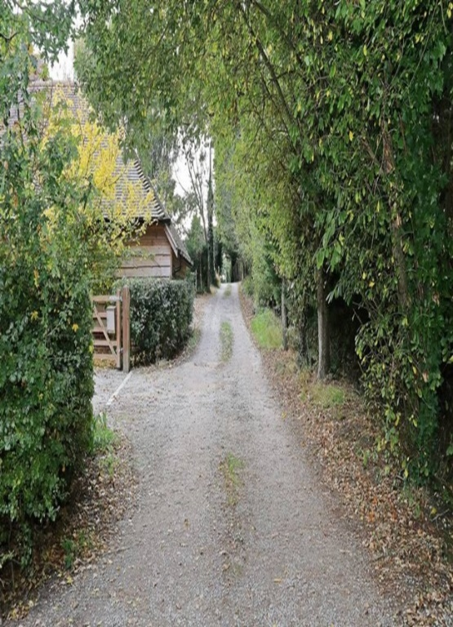

* Private driveways cannot be considered as an appropriate turning area
* If private driveways are considered to be access roads they should be capable of providing vehicular access as detailed above
* Due consideration has to be given to the maintenance of private driveways including trees, shrubbery and overhangs
* A risk assessment should be carried out for rural single dwellings that are beyond recommended guidance
* Demarcation markers maybe required to indicate actual usable road widths and soft verges
* A driveway and/or appliance may become damaged if an emergency vehicle enters an area that does not have suitable provision; this can seriously affect the response to an incident

Additional considerations

A question to ask when designing private driveways and plan on using th**em for fire services access is:**

*‘How will the crew, who are attending an emergency in the middle of the night, know if it is safe and suitable to use?’*

Fire hydrants do not directly feed the fire hose; the water must first pass through the fire appliance. This can create a 80+ metre travel distance to produce firefighting water e.g. **a** hydrant is located at the end of a driveway 35+ metres away from the appliance access point which is 45 metres away from the furthest point of a building, creating an unnecessary delay. Trees should not be planted next to hydrant as the roots block the hydrant outlet.

# 3 Water supplies for firefighting

Recommended minimum flow rates and location of fire hydrants

The Local Government Association (LGA)/Water UK National guidance document details the following flow rates as the minimum necessary for firefighting, in particular risk categories where new developments are under construction.

Housing

Minimum of 8 l/sec (480 l/min) for detached or semi-detached of not more than two floors, and dwellings of more than two floors minimum of 20 l/sec (1200 l/min) from any single hydrant on the development. Hydrants cannot be kept on water mains below 90mm nominal diameter and preferably be on a water main of 100mm nominal diameter.

Transportation

Minimum of 25 l/sec (1500 l/min) for lorry/coach parks, multi-storey car parks and service stations from any hydrant on the development or within a vehicular distance of 90 metres from the complex.

Industry (industrial estates)

It is recommended that the water supply infrastructure should provide as follows with the mains network on site normally being at least 150mm nominal diameter:

* Up to one hectare minimum of 20 l/sec (1200 l/min)
* One to two hectares minimum of 35 l/sec (2100 l/min)
* Two to three hectares minimum of 50 l/sec (3000 l/min)
* Over three hectares minimum of 75 l/sec (4500 l/min)

Note: High risk areas may require greater flow rates

Shopping, offices, recreation and tourism

Minimum of 20 l/sec (1200 l/min) to 75 l/sec (4500 l/min) depending on the nature and extent of the development.

Education, health and community facilities

* 1. **Village halls**

Minimum of 15 l/sec (900 l/min) through any single hydrant on the development or within a vehicular distance of 100 metres from the complex.

* 1. **Primary schools and single storey health centres**

Minimum of 20 l/sec (1200l/min) through any single hydrant on the development or within a vehicular distance of 70 metres of the complex.

* 1. **Secondary schools, colleges, large health centres and community facilities**

Minimum of 35 l/sec (2100 l/min) through any single hydrant on the development or within a vehicular distance of 70 metres from the complex.

Caravan sites - caravans/chalets

A fire hydrant should be located at the entrance to the site and if necessary, at 300 metre intervals. The hydrant should provide a minimum of 8 l/sec (480 l/min). If no piped water supply is available or where there is insufficient pressure or flow in the water main an alternative source must be provided. Suitable alternative sources are indicated on the following pages.

Building size

It is important to note that the current Building Regulations require an adequate water supply for firefighting. If the building has a compartment of 280m2 or more in area and there is no existing fire hydrant within 100 metres, a reasonable water supply must be available.

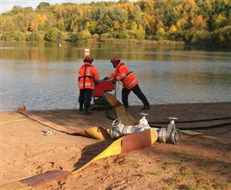

Where no piped water supply is available, or there is insufficient pressure and flow in the water main, or an alternative arrangement is proposed, the alternative water supply can be one of the following:

* A spring, river, pond or canal which is capable of storing or providing at least 45,000 litres of water at all times of the year
* A charged static tank of at least 45,000 litres capacity

With both of the above options, suitable access, space and hard standing for a pumping appliance must be provided as specified in tables 1 and 2. (see page 4/5)

For further details in relation to water provision for firefighting purposes please see below: <https://www.water.org.uk/publications/water-industry-guidance/national-guidance-document-provision-water-fire-fighting-3rd>

# 4 Regulatory Reform (Fire Safety) Order 2005

The Regulatory Reform (Fire Safety) Order applies to all premises apart from single private dwellings: <http://www.legislation.gov.uk/uksi/2005/1541/contents/made>

Once the buildings are in use, they become subject to the Fire Safety Order, imposing requirements that may be additional to those of the Building Regulations.

**General guidance: general fire precautions**

The Responsible Person must take such general fire precautions that will ensure, so far as is reasonably practicable, the safety of his/her employees and relevant persons who are not their employees. The term ‘general fire precautions’ means:

* Measures to reduce or eliminate the risk of fire on the premises and the risk of the spread of fire on the premises
* The provision of suitable means of escape from the premises
* Measures for ensuring that the means of escape can be safely and effectively used at all times
* The provision of suitable and adequate firefighting equipment
* The provision of suitable means for detecting and giving warning of a fire on the premises
* Measures for ensuring the maintenance and testing of fire precautions and

equipment

* The provision of suitable arrangements for the action to be taken in the event of a fire including:

1. Instruction and training for employees
2. Measures to mitigate the effects of a fire

**Fire risk assessment**

The Responsible Person must carry out a suitable and sufficient assessment of the risks to which persons are exposed to, for the purposes of identifying the general fire precautions measures to be taken in order to comply with ‘the Order’.

A series of guidance booklets have been published by Central Government to assist Responsible People with this process, and these can be downloaded from the following web link: [www.gov.uk/workplace-fire-safety-your-responsibilities/fire-safety-advice-documents](http://www.gov.uk/workplace-fire-safety-your-responsibilities/fire-safety-advice-documents).

# 5 Goodwill advice

Safeguarding people from the danger of fire in their homes and places of work is an emotive subject and unfortunately the fire services experience the consequences of failure on a regular basis.

Generally, through the application of approved guidance documents and the enforcement of regulations it is reasonable to assume that acceptable levels of fire safety within Northamptonshire are being provided. However, there are some factors particularly at the planning stage where the minimum standards fall short of what we consider being adequate.

Common areas of concern are:

* Planning applications in some rural areas where the response time of the nearest fire appliance can be up to 20 minutes
* The minimum access requirements for fire service vehicles cannot be met
* The risk profile of the building will be unknown until occupation takes place

***In circumstances where the guidance requirements cannot be met, the fire service recommends the installation of a fire suppression system, i.e. an automatic sprinkler system.***

****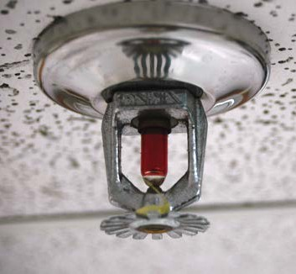

**Sprinklers and Suppression Systems**

An example of a commercial fire sprinkler, (left) and a concealed residential sprinkler head (right).

Inexpensive

Residential fire sprinklers cost less than two per cent of an average new house – or about the price of good carpeting.

Effective

Fire sprinklers are by far the most efficient and effective safety devices available, having a better than 97% success rate world-wide.

Life safety record

In the UK, statistics show that there has never been a multiple loss of life in a fully sprinklered building.

Early alarm

More than 50% of all fire casualties are either young or old, or physically incapacitated. In conjunction with smoke alarms, fire sprinklers sound the alarm when they go off so they increase the time people have to escape or be rescued.

Reliability

They are designed to last for 50 years and the chance of accidental operation, due to manufacturers’ defects, in service is 1:16,000,000 (one in sixteen million). Less than your chance of winning the lottery!

Operational facts

Each sprinkler is individually triggered by the heat of the fire and the system will gain control of the fire long before the Fire and Rescue Service is called. Only the sprinkler head near to the fire goes off - **not** all of them.

Limited water damage

Sprinklers use much less water than the Fire and Rescue Service. Because the sprinkler system tackles the fire immediately, it only has a small fire to deal with. In the event of a fire, the use of sprinklers will help minimise water damage.

Easy to install

Modern residential sprinklers are small, neat and unobtrusive and visitors are seldom able to spot them – concealed versions are now available.

Construction trade-offs

Sprinklers can save on construction costs because, under the Building Regulations, larger compartments or rooms may be constructed. Structural fire protection can also be reduced.

Environmental impact

Sprinklers can reduce greenhouse gas emissions by up to 98% and can also reduce fire damage, which ultimately means that less goes into our landfill sites.

Further guidance on residential sprinkler systems can be obtained by contacting:

The British Automatic Fire Sprinkler Association Ltd

Telephone: 01353 659 187

Website: [www.bafsa.org.uk](http://www.bafsa.org.uk)

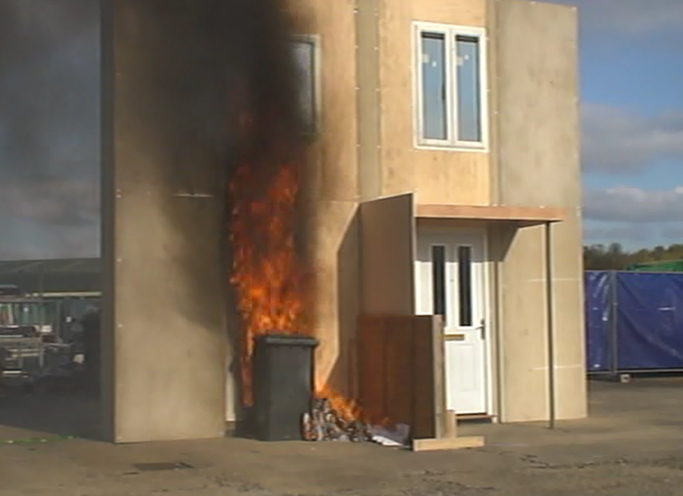**Waste and Recycling Provision (bin stores)**

The involvement of waste materials and wheelie bins in fires is often not recognised, so it is essential that safe, adequate waste management facilities (wheelie bin stores) are provided within all new developments. Combustible waste materials can attract and provide fuel for arsonists, and should therefore be secured.

NFRS ask developers to give careful consideration to the positioning of storage facilities for wheelie bins and ‘Euro’ Bins, and if no local adopted guidance is available would encourage developers to take on board the following points when designing schemes:

* Bin stores should, wherever possible, be external to the building, if this is not possible they **must not** be located in protected routes or stairwells, as in the event of fire this would compromise the escape route for any residents
* We recommend the ideal position for a bin store should be at least 8 metres away from any building
* Access to bin stores should not be sited next to escape routes, final exits or rear windows of dwellings
* Bin storage areas should be separated by structure giving 60 minutes fire resistance from the rest of the building
* Bin stores in Northamptonshire are currently constructed in a number of materials – timber, metal and brick, which all have their advantages; however NFRS prefer that bin stores are constructed from brick
* Exterior bin stores should be built where there is natural surveillance and reasonable lighting to improve security
* The store should be locked if possible with only residents having access
* The location of bin stores must not restrict access to fire hydrant locations
* To facilitate easy movement of refuse collection lorries, local authorities with responsibility for waste management may recommend that they should not be more than 15 metres from the highway, and residents should not have to travel more than 30 metres to deposit refuse

**Car parking provision**

Development schemes must have adequate off-street parking provision to reduce roadside parking and therefore reduce any impact on emergency service access and operational response times.

# 6 Planning out crime in Northamptonshire

NFRS work closely with Northamptonshire Police and other stakeholders to reduce crime and the fear of crime by ensuring that new developments incorporate crime prevention measures through design.

Crime and anti-social behaviour does not just impact on the police, but also on a wide range of other stakeholders, including NFRS. For example, poorly designed   
  
developments can increase the occurrence of crime and anti-social behaviour such as arson which leads to increased pressure on the Fire and Rescue Service.

It is therefore essential that developers take into consideration the principles set out within the ‘Planning out Crime in Northamptonshire’ Supplementary Planning Document (SPD) when designing schemes.

# 7 Final thoughts

This guide is aimed at providing the relevant guidance, and the reasoning for fire service needs, at the earliest opportunity thereby allowing the planning and design of developments to take into account Fire and Rescue Service needs in the event of a fire.

It is our view that by incorporating this guidance within designs will help create safer developments which, when the worst happens and fires occur, will have the provision to allow an effective emergency response.

There are numerous instances each year where officers are ask to meet with developers and architects and discuss issues with projects, sometimes at the very late stages e.g. the building are built. Solutions at such stages are always difficult and in some cases not possible, the outcome can be that premises are completed with a lesser provision than we would want or need.

We see that the provision of this guide and its use at the early stages would avoid the vast majority of issues and if not would allow for early proactive discussion prior to the point where alterations are not possible.