Business Fire Safety Awareness Tool (BFSAT)

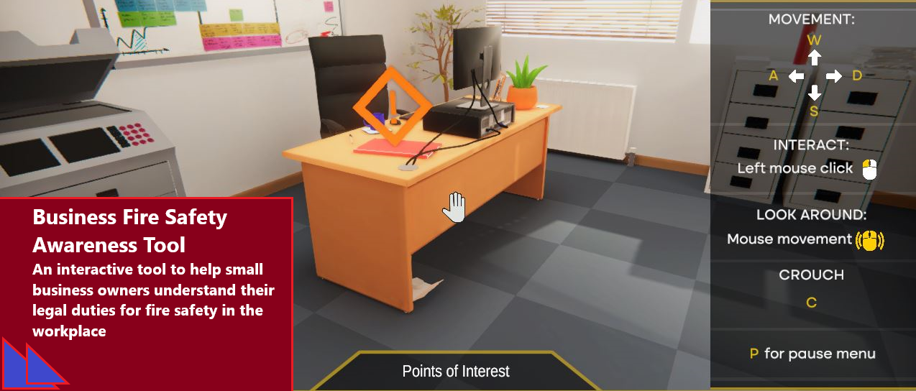

As the new owner or manager of a small business, the workplace fire safety law can seem quite daunting. This tool has been designed to give a fun and interactive experience whilst providing you with a general overview of your responsibilities following a fire risk assessment at your premises.
As you navigate around the workplace, correcting the issues identified and making it safer, you will be tested on your general fire safety knowledge.
You will need to set up an account and password the first time you access the BFSAT (this takes less than a minute).

Please note:
- You are only required to provide an email, password and the name of your local fire and rescue service to register
- There is no password recovery option if forgotten
- If you experience difficulty controlling movement around the tool, look to reducing the sensitivity of your mouse
Click here to take part in the interactive walkthrough:
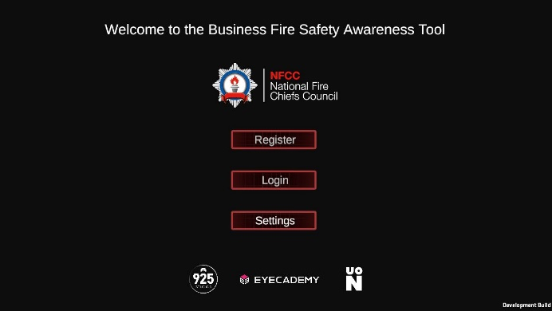

- This tool is for general fire safety awareness in the workplace, it is not intended as training tool for completing a Fire Risk Assessment.
Useful links
- Fire safety in the workplace: Who's responsible - GOV.UK (www.gov.uk)

- Finding fire risk assessor (nationalfirechiefs.org.uk)

- Fire safety law and guidance documents for business - GOV.UK (www.gov.uk)

- FSF Guide to Choosing a Competent Fire Risk Assessor (nationalfirechiefs.org.uk)

- Fire Sector Federation: Fire Safety Guidance and Advice

- List of UK fire and rescue services (nationalfirechiefs.org.uk)
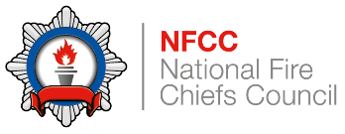
The Business Fire Safety Awareness Tool was developed by the NFCC in collaboration with Eyecademy and Northampton University. Funding was provided by the Department of Business Energy and Industrial Strategy.

