GIFTS AND HOSPITALITY REGISTER

Notification of gift/hospitality received by a member of staff of Northamptonshire Fire and Rescue Service (NFRS).

Name of staff member | Date received | Value/description | Log number
R. White | 17.08.2021 | 1 x pair of black safety boots and mask | 04/2021
R. Lloyd | 28.05.2021 | 4 x plant pots and various plants | 03/2021
K. Mitchell | 12.05.2021 | 2 x 24 bag boxes of crisps (retail value  £28.80) | 02/2021
J. Pratt | 12.05.2021 | 2 x 24 bag boxes of crisps (retail value  £28.80) | 01/2021
D. Dovey | 21.12.2020 | Christmas hamper | 02/2020
N. Dorrill | 11.05.2020 | Donation to watch food supplies | 01/2020
J. Miles | 11.12.2017 | 4 x ‘Aladdin’ pantomime tickets | 02/2017
P. Gletherow | 01.11.2017 | 2 x ‘Lulu: All about the music’ tickets | 01/2017
Ms D. Whittaker | 14.01.2016 | Two course lunch with coffee provided as an introductory meeting of community leaders | 01/2016
Mr D Moore | 30.06.2015 | Travel, accommodation and subsistence at various training courses | 02/2015
Mr M Emberson | 08.06.2015 | Accommodation, flights and subsistence at the trade show Interschutz in Germany | 01/2015
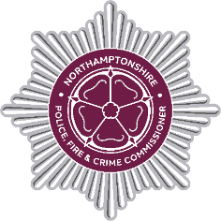
Gifts and hospitality received by NFRS staff between 2009-14 is available on request.

