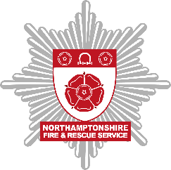
Northamptonshire Fire and Rescue Service (NFRS) Equality and Diversity Report
This report identifies the NFRS employment profiles as of 31 March 2022. NFRS capture full equality and diversity data via an online self-service portal which allows personnel to confidentially record all of their personal data.

Ethnicity:

Ethnicity recorded | Percentage
White British/Irish | 60.94%
Other White background | 1.50%
Black – African / Caribbean / British | 0.43%
Black – Other | 0.22%
Asian – Indian | 0.22%
Mixed – Caribbean | 0.43%
Mixed – Other | 0.86%
Not stated | 34.76%
Other | 0.64%
Religion:

Religion recorded | Percentage
Christian | 9.66%
None | 9.23%
Other | 0.43%
Prefer not to say | 1.07%
Not stated | 79.61%

Sexuality:

Sexuality recorded | Percentage
Heterosexual | 22.75%
Bisexual | 0.43%
Gay man | 0.00%
Gay woman/lesbian | 0.64%
Other | 0.64%
Prefer not to say | 1.07%
Not stated | 74.46%

Disability:

Do you have a disability? | Percentage
Yes | 0.21%
No | 99.79%

